Transcription and Translation

Elaine Ashby

BACKGROUND:

Headlines in papers and news magazines heralded the year 2000 as the year that the human genome had been decoded. What was actually determined was the nucleotide sequence of human DNA; a sequence of described by the letters A,T,G, and C. To further understand the genetic code we must examine how cells use that code to make proteins. DNA must be decoded, first transcribed or copied into RNA in the nucleus, and then this RNA is translated into protein in the cytoplasm.
The purpose of this laboratory is to use models to illustrate how the cell converts the genetic code into a functioning protein, and what happens when changes occur in DNA. The following is a quick overview of Replication, Transcription, and Translation, as you go through this lab and attempt to answer questions, you may wish to turn to your text for a more complete explanation.

Replication: (PROCESS FOR COPYING DNA)
Replication is the process by which each cell copies its complete genetic code in order to be able to reproduce. Replication occurs in the nucleus and is initiated during the S stage of the cell cycle. In order for DNA to be replicated it must be unwound and hydrogen bonds between complementary bases in the double stranded DNA must be broken. This occurs with the help of enzymes known as helicases. Once the DNA is exposed a nuclear enzyme called DNA polymerase III moves into place at the 3’ end of an opening made by the helicases. New nucleotides move in and begin building a new strand of DNA in a 5’ to 3’ direction. An adenine comes in or pairs wherever there is a complementary thymine on the existing strand, a thymine where there is an adenine, a guanine where there is a cytosine, and a cytosine where there is a guanine. This continues until all DNA is copied.

Transcription: (PROCESS FOR MAKING RNA)
Transcription or making RNA occurs throughout the cell cycle in the nucleus whenever new proteins need to be made. Upstream promoter sequences signal to RNA polymerase to bind to DNA and build RNA in a 5’ to 3’ direction. RNA is similar to DNA except the sugar ribose replaces deoxyribose, the nucleotide Uracil also replaces the nucleotide Thymine in DNA. The transcript is built by complementary base pairing with an adenine pairing with each thymine on DNA, guanine to cytosine, cytosine to guanine, and uracil pairing with each adenine on the DNA. The RNA transcript continues to build until a “stop” code is reached on the DNA. Many Eukaryotic RNA transcripts undergo additional posttranscriptional modifications before leaving the nucleus and reaching the ribosome where RNA is translated to protein.

Translation: (PROCESS FOR MAKING PROTEIN)
Translation begins in the cytoplasm at the ribosome, an organelle that is composed of two RNA and protein sub-units. A start sequence on a messenger RNA, the nucleotide sequence AUG binds to the ribosome at what is known as the P site. Another type of RNA called a transfer RNA has the ability to complementary base pair three nucleotides at a time with the messenger RNA. It also binds to a specific amino acid and brings it to the ribosome. When the transfer RNA pairs with its specific sequence on the messenger RNA in the A site of the ribosome, it will bind its amino acid to the next in the ribosome and begin to grow a protein. This will continue until a stop codon or three base sequence has been reached. The “code” of messenger RNA has been determined and can be found in your textbook.

OBJECTIVES:

-Students will use paper and pencil to replicate DNA using a known sequence from the globin gene.
-Students will determine which enzymes are necessary for replication, which direction replication occurs in, which bases are complementary and learn the meaning of the terms: semi-conservative replication and antiparallel strands.
-Students will use paper and pencil to transcribe the DNA into a mRNA sequence recognizing that Uracil replaces Thymine in RNA, that RNA is single stranded.
-Students will determine which enzymes are necessary for transcription and where transcription occurs, which direction it occurs in.
-Students will look at the complete sequence of nucleotides that make up beta globin and identify introns, the methionine “cap”, and the “poly-A” tail sequence.
-Students will translate an RNA sequence into protein.
-Students will learn about the mutation that causes sickle cell anemia and trace it back to the original DNA sequence.
-Students will explore the effect of the change of a nucleotide on the shape of this protein.
-Students will research how the sickle cell mutation causes disease.
-Students will look at how DNA sequences can be used to examine evolutionary relationships.

PROCEDURE:

Replication
Each student will be given a Replication worksheet that contains part of the code for the gene for beta globin, one of four polypeptide chains that make up adult hemoglobin.

1. Fold the sheet in half, and then fold the front half backward. Since DNA is double stranded, the folded paper demonstrates the double helix.

- In order to replicate DNA, the hydrogen bonds between nucleotides must first be broken. We represent this by unfolding the paper. Each of the two strands now represents a template on which with the help of DNA polymerase, new DNA strands can be built.

- Build complementary strands of DNA by writing an A in the “new DNA” column adjacent to every T; a G next to each C; a C next to each G, and a T next to each A. Make sure to build the new strand in a 5’ to 3’ direction.

- Cut the worksheet in half down the line or fold in the middle. You have now copied one double stranded DNA to make two.

Transcription:

- Each student will be given a transcription and translation worksheet that contains part of the code for the gene for beta globin, on the right hand side. Fold the sheet in half, and then fold the front half backward.

- In the left hand column that is labeled DNA, get more practice with replication by replicating the DNA using complementary base pairing, remember to replicate in a 5’ to 3’ direction. (Remember that replication is not part of transcription.)
- In the column labeled RNA, transcribe the RNA by filling in complementary bases to the DNA column on the left. Make sure to replace T with U.

Translation:

- Translation will be completed on the same worksheet we just used. Translation requires a ribosome and transfer RNA. We will use a plastic template to represent the ribosome. Transfer RNA has been color coded to differentiate between the characteristics of different amino acids, some are polar (yellow), non-polar (white), acidic (pink), and basic (blue). Place the plastic ribosome over the first codon and bring in a transfer RNA with a complementary anticodon.
- In the column labeled Protein, fill in the amino acid and note its characteristics. Continue until you have transcribed the entire RNA sequence.

Beta Globin gene sequence and post-transcriptional modification

- Examine the RNA sequence below, it contains information about the genetic code for Beta Hemoglobin, one of four amino acid chains that make up adult hemoglobin.
- Note that the lighter colored sequence has no amino acids listed next to it. This sequence is called an “intron” a non-coding region within the code for Beta globin which will be spliced out by enzymes before transcription occurs. There is also a long “tail” of nucleotides after the final codon that does not code for any additional amino acids.
- The first amino acid that is coded for, methionine is also not part of the final beta globin chain. Enzymes cut off the methionine after translation.
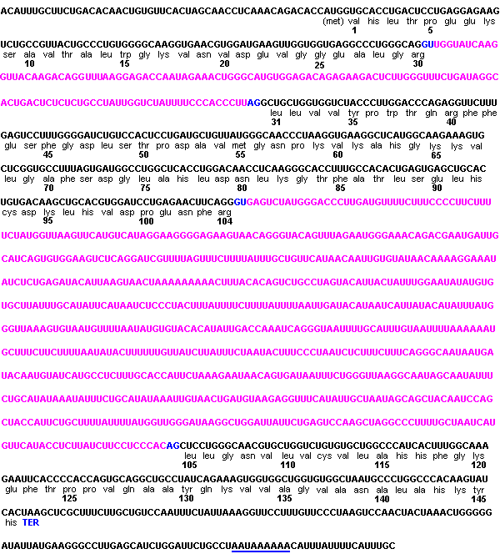
- The steps above (2 &3) are known as post-transcriptional modification.

- Try finding the nucleotide or amino acid sequence of beta hemoglobin on the Internet by searching “genbank” or doing a general search for the human beta globin gene. (HUMHBB) (http://www.ncbi.nlm.nih.gov/Genbank/GenbankSearch.html)

Hemoglobin Mutants: Missense, Nonsense, and Frameshift

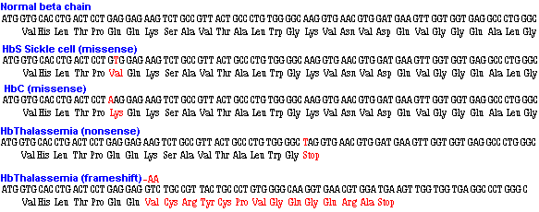

- The top line above shows the DNA code and amino acid sequence for the first 29 amino acids of the beta globin chain. The next four lines show the same information for four, different mutants. The changed base and amino acid(s) are slightly lighter in color. HbS and HbC are both missense mutants at the #6 amino acid position substituting valine or lysine for glutamic acid. Hb Thalassemia is a general name for a reduction in the amount of hemoglobin produced. The first HbThal mutant shown has a Stop or Termination codon (TAG) at position #17 in place of the codon for lysine. The second HbThal mutant results from the deletion of two adjacent adenines at position #8 causing a shift in the reading frame to produce a series of missense amino acids terminating at a now in-phase, early termination codon.
- Highlight or circle the location of the mutation.
- In the evaluation describe the difference between the three types of mutations. Could a mutation occur without changing the protein?

Sickle Cell and Disease
Look at either of these web sites and answer the question, How does sickle cell cause disease?
http://www.cdc.gov/genetics/hugenet/reviews/sickle.htm#Gene
http://sickle.bwh.harvard.edu/scd_background.html

Evolution and DNA

Whenever cells replicate there is a chance for a copying error. When DNA is exposed to mutagens, there is the chance for a mutation. Over time mutations change the genetic code; if they change the phenotype of the individual in a way that makes them more fit to survive, the mutations will persist. If they occur in non-coding regions of the gene that doesn’t effect phenotype, they will also persist.

Science uses this information to look at the evolutionary relationship between organisms. Look at the amino acid composition of the five animals below and attempt to determine which are most closely related.

Comparison of Beta Hemoglobin of Different species

First 50 amino acids:

Human 1 MVHLTPEEKSAVTALWGKVNVDEVGGEALGRLLVVYPWTQRFFESFGDLS 50

Gorilla 1 MVHLTPEEKSAVTALWGKVNVDEVGGEALGRLLVVYPWTQRFFESFGDLS 50

Rabbit 1 MVHLSSEEKSAVTALWGKVNVEEVGGEALGRLLVVYPWTQRFFESFGDLS 50

Bovine 2 LTAEEKAAVTAFWGKVKVDEVGGEALGRLLVVYPWTQRFFESFGDLSTAD 51

Mouse 1 MVHLTDAEKAAVSCLWGKVNSDEVGGEALGRLLVVYPWTQRYFDSFGDLS 50

Calculate the Percent similarity between the first 50 amino acids of human hemoglobin and each of the other four species.

The gene sequences and hemoglobin mutants described are used with the permission of Robert Huskey of the University of Virginia (rjh9u@virginia.edu). These sequences and more information can be found on his Biology 121, Human biology web site: (http://www.people.virginia.edu/~rjh9u/humbiol.html)

Evaluation

- In DNA Replication _____________binds to ______________; and ____________ binds to _____________.

- The enzyme involved in unwinding DNA is known as a ____________.

- The enzyme involved in building a complementary strand of DNA is_____________.

- Replication occurs in a _____ to ______ direction.

- When DNA is replicated, the new DNA that is produced is composed of one “old” strand that serves as a template and a new strand, this is known as _______ replication.

- DNA is said to be antiparallel. What does this mean?

- RNA differs from DNA because there is a different base, _______ that replaces __________ in DNA.

- This unique RNA base is complementary to the base__________________________.

- Transcription occurs where? ____________________________

- What enzyme is responsible for transcribing DNA? ________________________

- The entire sequence that is transcribed is known as a primary transcript. What modifications will happen to this RNA before it is translated?

- What happens to newly transcribed RNA before it is translated?

- The sequence of three nucleotides on a messenger RNA that code for an amino acid is known as a/an ______________.

- The sequence of three complementary nucleotides on a transfer RNA is known as a/an __________.

- Each transfer RNA brings a specific _____________ to the ribosome, which will be added to others to build a ______________.
- What is the role of the ribosome?

- If a messenger RNA contained 72 nucleotides, how many amino acids would be found in the protein it coded for?
- Which is translated, the intron or exon?
- Hypothesize a purpose for the nucleotide tail found on mRNA.

- Describe the missense mutation that causes HbS, the sickle cell mutation. How does valine, the seventh amino acid in sickle cell beta Hemoglobin differ from glutamine, the amino acid it replaces. Will a point mutation always cause a change in the protein that is coded for?

- How could a change in one amino acid in a protein change its function?

- What is a nonsense mutation?

25. Describe the frameshift mutation that causes Thalessemia:

26. The following code for Beta Hemoglobin was extracted from a GenBank database. How many nucleotides does it contain? Why are there so many more nucleotides in this sequence than in the primary transcript?
Beta Hemoglobin is coded for in the region: nucleotides 62187-63610

62161 ttcactagca acctcaaaca gacaccatgg tgcacctgac tcctgaggag aagtctgccg
62221 ttactgccct gtggggcaag gtgaacgtgg atgaagttgg tggtgaggcc ctgggcaggt
62281 tggtatcaag gttacaagac aggtttaagg agaccaatag aaactgggca tgtggagaca
62341 gagaagactc ttgggtttct gataggcact gactctctct gcctattggt ctattttccc
62401 acccttaggc tgctggtggt ctacccttgg acccagaggt tctttgagtc ctttggggat
62461 ctgtccactc ctgatgctgt tatgggcaac cctaaggtga aggctcatgg caagaaagtg
62521 ctcggtgcct ttagtgatgg cctggctcac ctggacaacc tcaagggcac ctttgccaca
62581 ctgagtgagc tgcactgtga caagctgcac gtggatcctg agaacttcag ggtgagtcta
62641 tgggaccctt gatgttttct ttccccttct tttctatggt taagttcatg tcataggaag
62701 gggagaagta acagggtaca gtttagaatg ggaaacagac gaatgattgc atcagtgtgg
62761 aagtctcagg atcgttttag tttcttttat ttgctgttca taacaattgt tttcttttgt
62821 ttaattcttg ctttcttttt ttttcttctc cgcaattttt actattatac ttaatgcctt
62881 aacattgtgt ataacaaaag gaaatatctc tgagatacat taagtaactt aaaaaaaaac
62941 tttacacagt ctgcctagta cattactatt tggaatatat gtgtgcttat ttgcatattc
63001 ataatctccc tactttattt tcttttattt ttaattgata cataatcatt atacatattt
63061 atgggttaaa gtgtaatgtt ttaatatgtg tacacatatt gaccaaatca gggtaatttt
63121 gcatttgtaa ttttaaaaaa tgctttcttc ttttaatata cttttttgtt tatcttattt
63181 ctaatacttt ccctaatctc tttctttcag ggcaataatg atacaatgta tcatgcctct
63241 ttgcaccatt ctaaagaata acagtgataa tttctgggtt aaggcaatag caatatttct
63301 gcatataaat atttctgcat ataaattgta actgatgtaa gaggtttcat attgctaata
63361 gcagctacaa tccagctacc attctgcttt tattttatgg ttgggataag gctggattat
63421 tctgagtcca agctaggccc ttttgctaat catgttcata cctcttatct tcctcccaca
63481 gctcctgggc aacgtgctgg tctgtgtgct ggcccatcac tttggcaaag aattcacccc
63541 accagtgcag gctgcctatc agaaagtggt ggctggtgtg gctaatgccc tggcccacaa
63601 gtatcactaa gctcgctttc ttgctgtcca atttctatta aaggttcctt tgttccctaa
63661 gtccaactac taaactgggg gatattatga agggccttga gcatctggat tctgcctaat

1

Transcription/Translation Worksheet

DNA RNA PROTEIN DNA

5’

A
T
G

G
T
G

C
A
C

C
T

G

A
C
T

C
C
T

G
A
G

G
A
G

A
A
G

T
C
T
3’
2

Transcription/Translation Worksheet

DNA RNA PROTEIN DNA
5’
G
C
C

G
T
T

A
C
T

G
C
C

C
T
G

T
G
G

G
G
C

A
A
G

G
T
G

A
A
C

G
T
G
3’

3

Transcription/Translation Worksheet

DNA RNA PROTEIN DNA
5’
G
A
T

G
A
A

G
T
T

G
G
T

G
G
T

G
A
G

G
C
C

C
T
G

G
G
C

A
G
G

C
T
G
3’
1

Replication Worksheet

DNA New DNA New DNA DNA

3’ 5’

T A

A T

C G

C G
A T
C G

G C
T A
G C

G C
A T
C G

T A

G C
A T

G C
G C
A T

C G
T A
C G

C G
T A
C G

T A
T A
C G

A T
G C
A T
5’ 3’
2

Replication Worksheet

DNA New DNA New DNA DNA
3’ 5’

C G
G C
G C

C G
A T
A T

T A
G C
A T

C G
G C
G C

G C
A T
C G

A T
C G
C G

C G
C G
G C

T A
T A
C G

C G
A T
C G

T A
T A
G C

C G
A T
C G
5’ 3’

3

Replication Worksheet

DNA New DNA New DNA DNA
3’ 5’

C G

T A

A T

C G
T A
T A

C G
A T
A T

C G
C G

A T

C G
C G
A T

C G
T A
C G

C G
G C
G C

G C
A T
C G

C G
C G
G C

T A
C G
C G

G C
A T
C G
5’ 3’

